Reversible Rover

Subject: Automotive Engineering  Related Subjects:Electronics Engineering,Mechanical Engineering | Grade Level(s):  Length of Lesson: | Type: Inquiry / Design / Project  Keywords:Series circuit, gearing, axle, chassis, alignment, horsepower (torque x rpm), suspension

Lesson Overview
Use this section to describe at a high level what the lesson is. Should be no more than 3-4 lines.

Lesson Focus
What is the central question or phenomenon being investigated? What problem are they trying to solve?

Lesson Objective(s) | By the end of this lesson, students will…  - Build suspension (wheels and axles) from cans, foam core and wood dowels.  - Build chassis from wood base shoe and foam core.  - Create series circuit with motor, batter holder and switch  - Assemble USC rover  - Demonstrate mechanical advantage by connecting gears (motor stem to can wheel) via rubber band.  - Determine which design leads to better performance in  - Speed  - Direction  - Incline  - “Off road” conditions  - Will also demonstrate trade-off of beauty versus function

Lesson Timing

5 minutes | Introduce the Lesson
30 minutes | ...

Materials | - Foam core  - Wood dowels  - Wood base shoe  - Soda cans  - 1.5V motor  - Battery holder  - 2 position switch  - Wire  - Solder core resin  - Soldering Iron  - Glue gun and glue sticks  - Decorative material  - Wire stripper  - Rubber bands
Instructor Prep | - Step 1
Related Resources | - List related lessons/ppts etc available from USC or outside, trusted orgs

Lesson Plan

Introduction
Introduce students to the learning goals and make connections to past and present learning experiences. Stimulate interest and prompt students to identify their own questions about the topic. This can link the lesson to real world examples, introduce associated STEM careers, and assess their prior knowledge on the topic.

- Step 1

Procedure
List the steps of the activity. Remember to focus on leading students to the solution, rather than just telling them what to do. Include pictures of steps if you have them. Be sure to include some steps for discussion and reflection.

- Measure and cut four circles of foam core the same size as the end of a soda can.
- Glue circles to both ends of each soda can (figure 1).
- Cut 2 dowels about 3 inches longer than the soda cans.
- Drill a hole in both ends of both soda cans (through the foam core).
- Insert a dowel through both holes of one soda can (this is the wheel- axle)
- Repeat step for the other can.
- Cut a rectangle from the foam core (the width must be longer than a soda can).
- Cut a “V” in one end.
- Cut 2 pieces of wood base shoe. The wood must be long enough for both cans to spin freely when connected to the chasis.
- Drill a hole in each end of one piece of wood.
- Measure and mark the holes from the first piece of wood to the second to make sure the holes line up.
- Drill a hole in each end of the other piece of wood where marked.
- Glue the foam core to the pieces of wood using the “H” shaped model (figure 2).
- Cut and strip 4 pieces of wire
- Strip the wires of a battery holder.
- Twist ends of two wires and solder to one lead of motor.
- Twist ends of remaining two wires and solder to second lead of motor.
- Solder the one wire of twisted pair from one motor lead to top lead of switch on one side.
- Solder the other wire of twisted pair from one motor lead to top lead of switch on other side.
- Solder the one wire of twisted pair from 2nd motor lead to top lead of switch on one side.
- Solder the other wire of twisted pair from 2nd motor lead to top lead of switch on other side.
- Solder red wire of battery holders wires to middle lead of switch.
- Solder black wire of battery holders wires to middle lead of switch on other side (figure 3b).
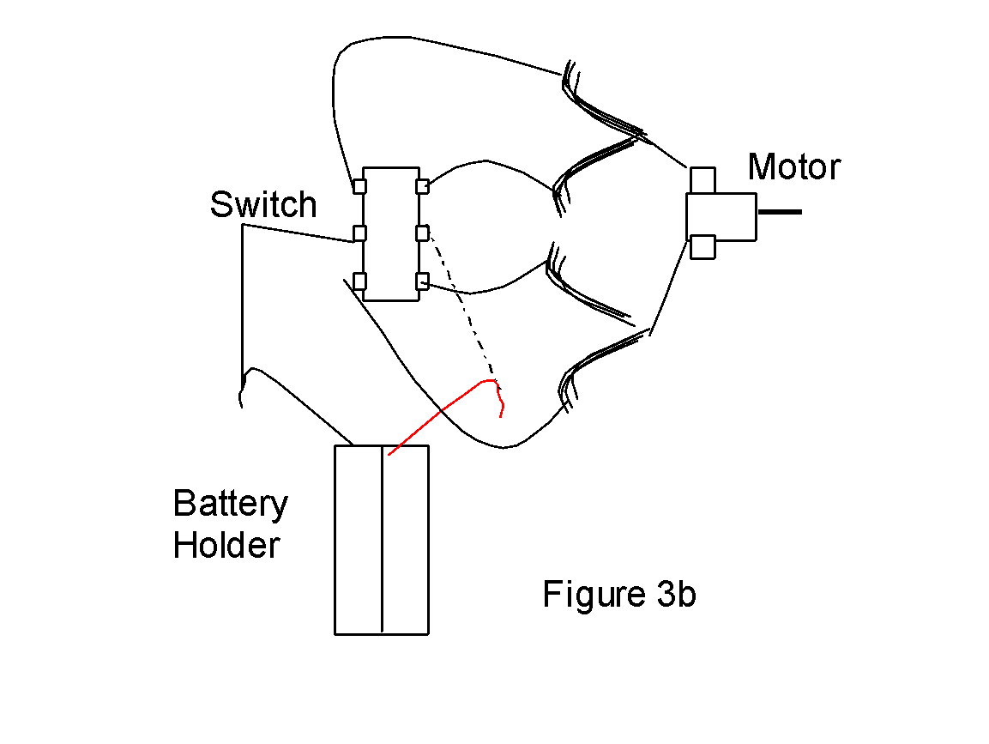
- Test circuit with batteries.
- Place three rubber bands around each can.
- Attach wheel-axle suspension to chassis by inserting dowel ends into holes of wood on both ends (figure 4 below).
- Secure wheel-axle by wrapping rubber bands on both ends of axle (on outside of wood base shoe) front and back.
- Place tape over openings on motor and glue motor to chassis with the stem parallel to wheel axis and over the “V” (figure 5) Stem facing right makes car move one way, stem facing left makes car move the other way. Student must test before gluing to determine which way to glue motor.
- Glue battery holder and switch to foam core or wood.
- Place rubber band from can around stem of motor (student may have to place holder on end of stem to keep rubber band from sliding off).

Wrap-up
End the lesson with some final discussions about what students designed/discovered. Connect their activity back to the focus question/problem, real world examples, and STEM careers.

Also include notes about any special cleanup considerations

Lesson Background for Teachers

Suggested Real-World STEM Connections
- List possible related Role Models in STEM (with details and links to more reading). Give suggestions for examples of scientists/engineers who are from underrepresented groups in STEM in related careers.
- List related real-world engineering problems and examples

Lesson Variations and Options
Include descriptions of alternative methods or ways to present things.

Explanation
Describe the background concepts and explanations behind the lesson. This can be more in depth than a teacher/instructor would actually share with students.

Key Concepts and Vocabulary
- Word 1: Grade Appropriate Definition
- Word 2: Grade Appropriate Definition

Safety Notes
- Safety instruction

